**Prasanna Nimbalkar**

**NUID: 002111122**

**PART 3 - PROGRAMMING ASSIGNMENT**Create a database for a Contact Management System in MongoDB.  
You could use any attributes you like, first name, last name, phone, address, zip, etc.

Create 5 records with different attributes and values you choose.

Then delete any one record of your choice.

Then update some information from any one of the records of your choice.

**PART 4 - PROGRAMMING ASSIGNMENT**You could take the screenshots by pressing ALT + PRT SCRN or Snipping Tool every time you execute a command, and paste into a word document. You could then submit this document.

Create a collection called ‘games’. We’re going to put some games in it.  
Add 5 games to the database. Give each document the following properties: name, genre, rating (out of 100)

If you make some mistakes and want to clean it out, use remove() on your collection.  
Write a query that returns all the games.

Write a query to find one of your games by name without using limit().

Use the findOne method.

Look how much nicer it’s formatted!

Write a query that returns the 3 highest rated games.

Update your two favorite games to have two achievements called ‘Game Master’ and ‘Speed Demon’, each under a single key.  
Show two ways to do this.

Do the first using update() and do the second using save().  
Hint: for save, you might want to query the object and store it in a variable first.

By Using Update



By Using save

Write a query that returns only games that have achievements.  
Not all of your games should have achievements, obviously.

**PART 5 - PROGRAMMING ASSIGNMENT**Execute 5 commands of your choice from each of the following groups, and paste the screenshots in a word document.

mongo> help             [5 commands]

1. show collections --Displays collections database

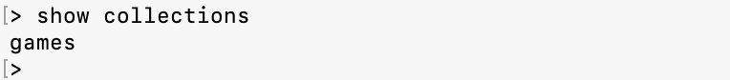

1. show dbs

1. use <db_name>

1. show profile

1. DBQuery.shellBatchSize = X



mongo> db.help()        [5 commands]

1. db.hostInfo()

1. db.getName()

1. db.version()

1. db.getMongo()

1. db.stats()

mongo> db.mycoll.help() [10 commands]

1. db.myColl.dataSize()

1. db.myColl.count( query = {}, <optional params> )

1. db.mycoll.renameCollection( newName , <dropTarget> )

1. db.mycoll.findOneAndUpdate( filter, <update object or pipeline>, <optional params> )

1. db.mycoll.totalSize()

1. db.mycoll.countDocuments( query = {}, <optional params> )

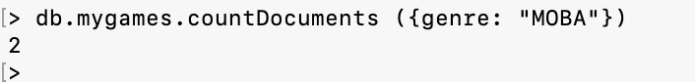

1. db.mycoll.aggregate( [pipeline], <optional params> )

1. db.mycoll.totalSize()



1. db.mycoll.find(...).limit(n)

1. db.mycoll.distinct( key, query, <optional params> )

